the principal directions of the considered PCA components (either find a
way to plot them or interpret them in terms of the features),

Since we are working with data that has more than 3 dimensions, it is hard to plot all principal components. Nevertheless, matrix V depicts directions of the principal components.
All PCA components coefficients (matrix V):
[INSERT MATRIX V IN FORM OF COOL LOOKING TABLE]
For instance, for analyzed data the first three components explain more than 80% of the variance. By plotting their coefficients, we can see that PC2 has large coefficients of mcg, gvh and alm2 attributes, thus these features will be “favorized” during projection onto PC2.
[FIGURE 3 – MAKE IT GOOD LOOKING]
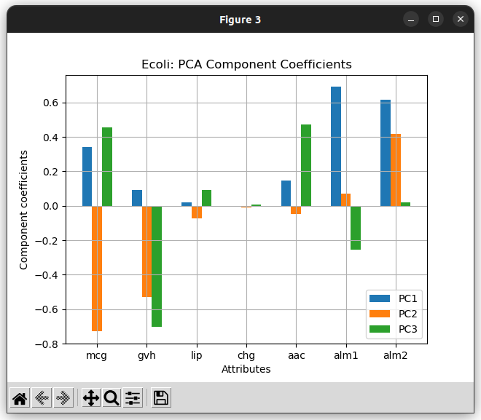
Example:
PCA2 coefficients (this is 7x1 matrix, format in final report):
[-0.72982496 -0.52879438 -0.07250123 -0.01168094 -0.04804968 0.07212754 0.41812439]
First observation in Ecoli dataset:
[0.49 0.29 0.48 0.5 0.56 0.24 0.35]
The result of multiplying above matrixes is the projection of this observation onto PC2:
projected_val = -0.41485933061758706

